If you forget the password of you VM, you cannot setup a new VM directly, because you can only own one storage. Before you set up a new VM, you should delete the storage first. The step is below.

1. Click the storage

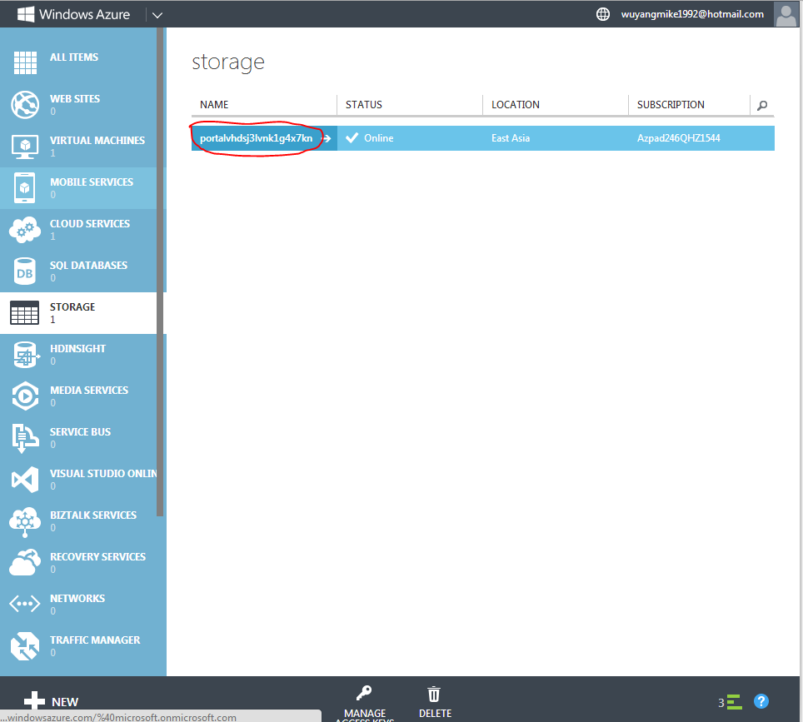

1. Click the area which is circled by red.

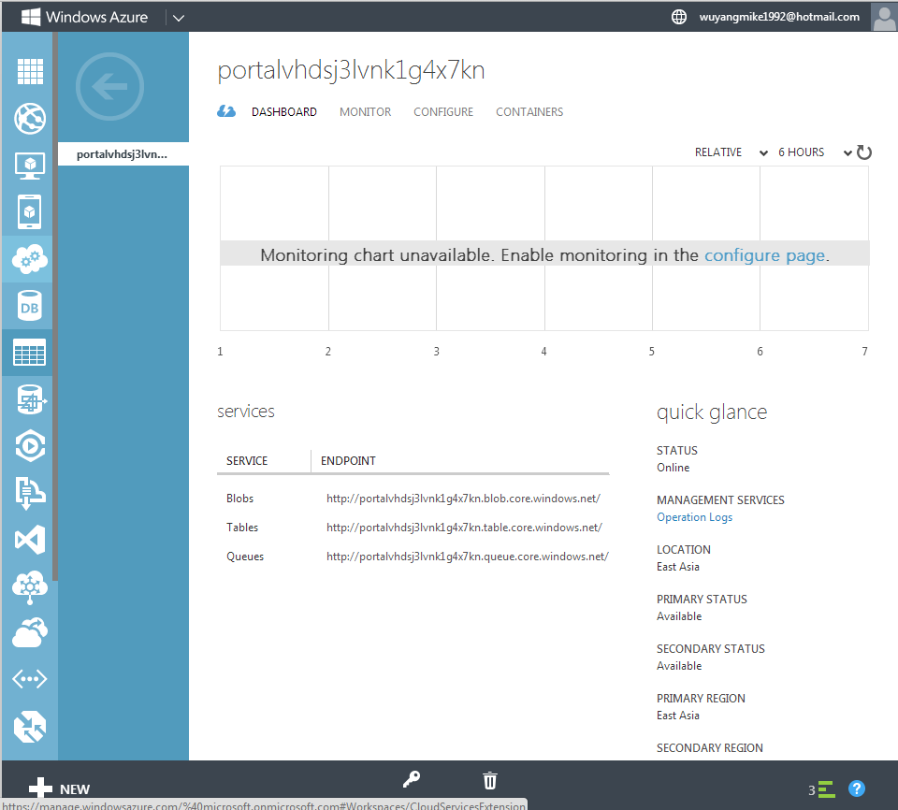

1. Click CONTAIN

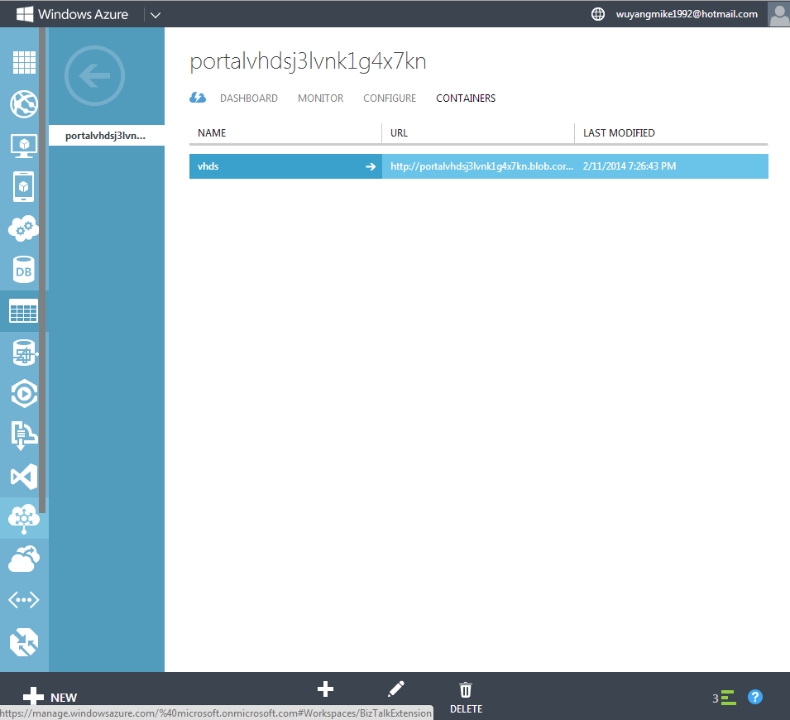

1. Click vhds and delete it

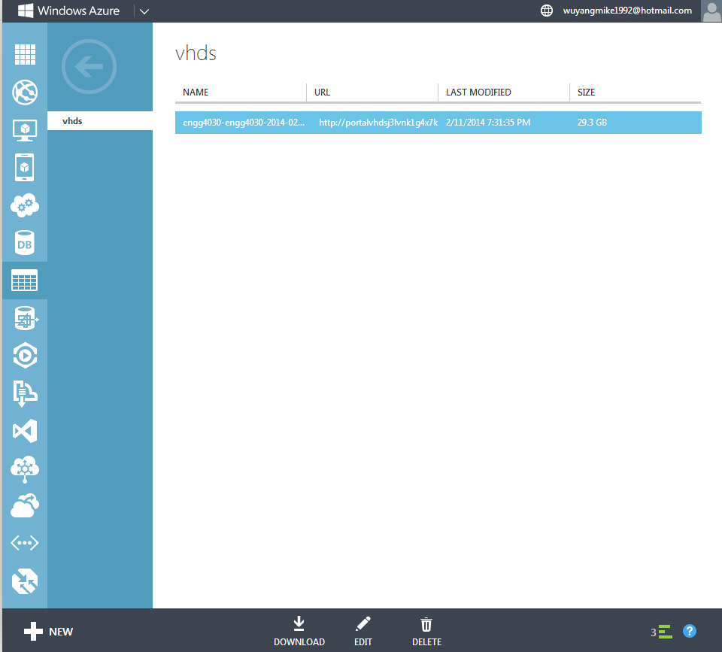

1. Then you can delete the storage and set up a new VM